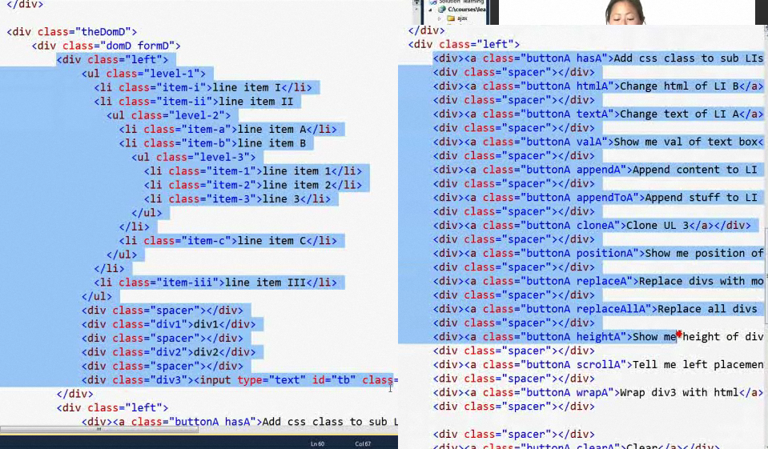

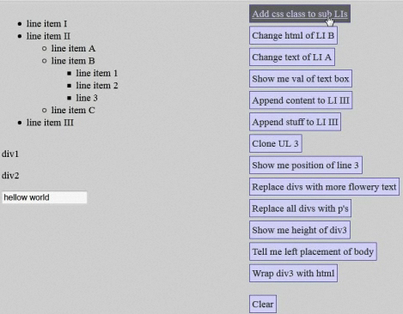

|  |  |
| --- | --- |
| Add css class to sub LIs |  |
| Using css |  |
| Using html    Si en vez de **html** ponen **text** entonces lo que mostraria en vez de heart es  <span class=’orangeborder’>heart</span> |  |
| Get what is in a text box, in value  <**input** type="**text**" id="**txName**" value="**hello world**" />  $(“#t**xName**”).**val()** |  |
| append |  |
| appendTo    <div class="div1">div1</div> |  |
| Clone UL3 |  |
| Position |  |
| ReplaceWith |  |
|  |  |
|  |  |